National University of Computer and Emerging Sciences, Islamabad
FAST School of Computing


CS4031 - Compiler Construction Assignment 01
Automata Design

Submitted by
Muhammad Fatik Bin Imran (23i-0655)
Muhammad Kaleem Akhtar (23i-0524)

Bachelor of Computer Sciences
2025
Lecturer
Dr Mahreen Alam

Contents
1. Regular Expressions 3
2. NFA 5
2.1 Arithmetic operators 5
2.2 Boolean 5
2.3 Float 5
2.4 ID 5
2.5 Integer 6
2.6 Punctuator 6
2.7 Single-line comment 6
3. DFA 6
3.1 Arithmetic operators 6
3.2 Boolean 7
3.3 Float 7
3.4 ID 8
3.5 Integer 8
3.6 Punctuator 8
3.7 Single-line comment 9

1. Regular Expressions
RE (Fate Language)
Keywords:
(start|finish|loop|condition|declare|output|input|function|return|break|continue|else)

1. Identifiers:
[A-Z][a-z0-9_]{0,30}

2. Integer Literals:
[+-]?[0-9]+

3. Floating-Point Literals:
[+-]?[0-9]+\.[0-9]{1,6}([eE][+-]?[0-9]+)?

4. String Literals:
"([^"\n\r\\]|\\["\\ntr])*"

5. Character Literals:
'([^'\n\r\\]|\\['\\ntr])'

6. Boolean Literals:
(true|false)

7. Operators:
Arithmetic: (\*\*|[+\-*/%])
Relational: (==|!=|<=|>=|<|>)
Logical: (&&|\|\||!)
Assignment: (\+=|-=|\*=|/=|=)
Inc/Dec: (\+\+|--)

8. Punctuators:
[(){}\[\],;:]

9. Comments:
Single-line: ##[^\n]*
Multi-line: #\*([^*]|\*+[^*#])*\*+#

10. Whitespace (skip but track line/column):
[ \t\r\n]+

Priority Order (highest to lowest):
1. Multi-line comments
2. Single-line comments
3. Multi-character operators (**, ==, !=, <=, >=, &&, ||, ++, --, +=, -=, *=, /=)
4. Keywords
5. Boolean literals
6. Identifiers
7. Floating-point literals
8. Integer literals
9. String literals
10. Character literals
11. Single-character operators
12. Punctuators
13. Whitespace

2. NFA

2.1 Arithmetic operators
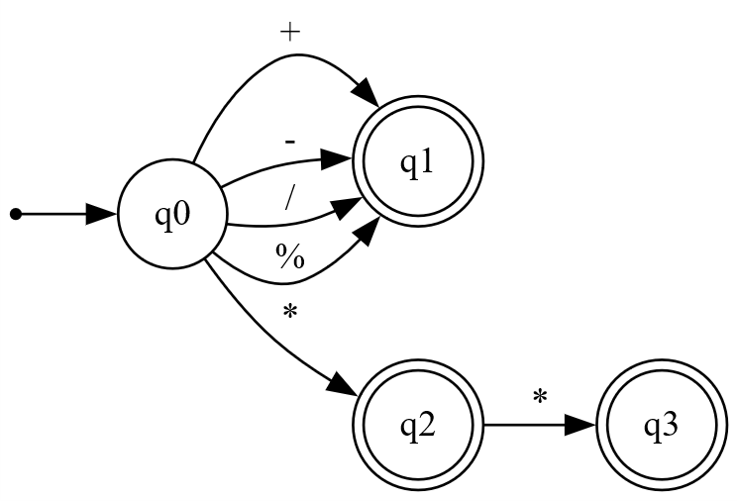

2.2 Boolean
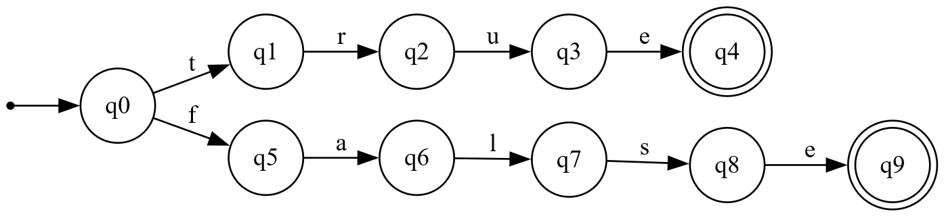

2.3 Float
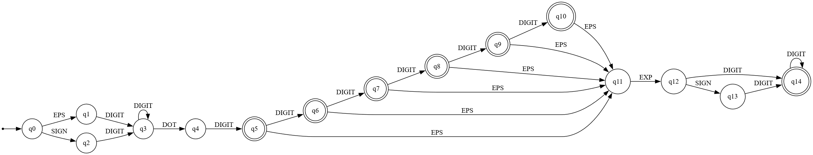

2.4 ID

2.5 Integer
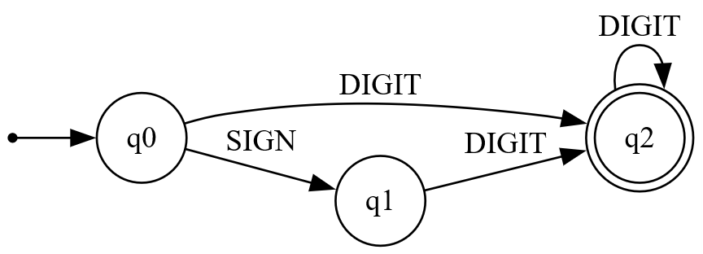

2.6 Punctuator
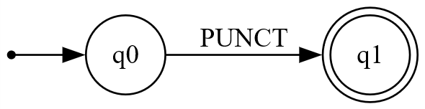

2.7 Single-line comment
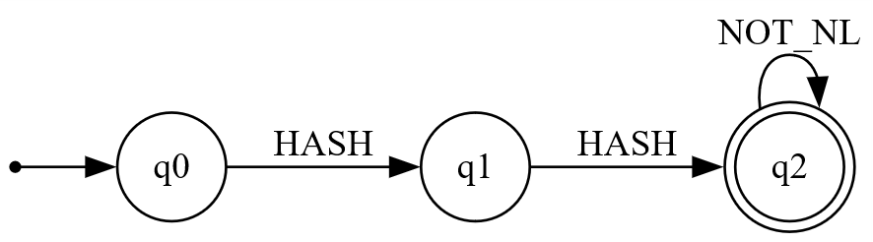

3. DFA

3.1 Arithmetic operators
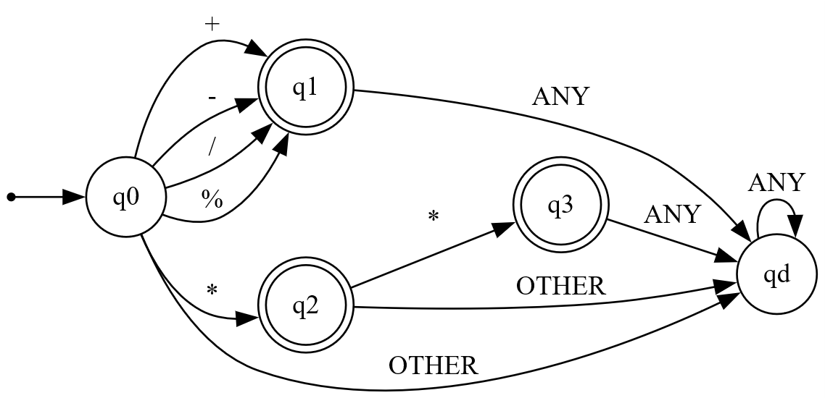

3.2 Boolean

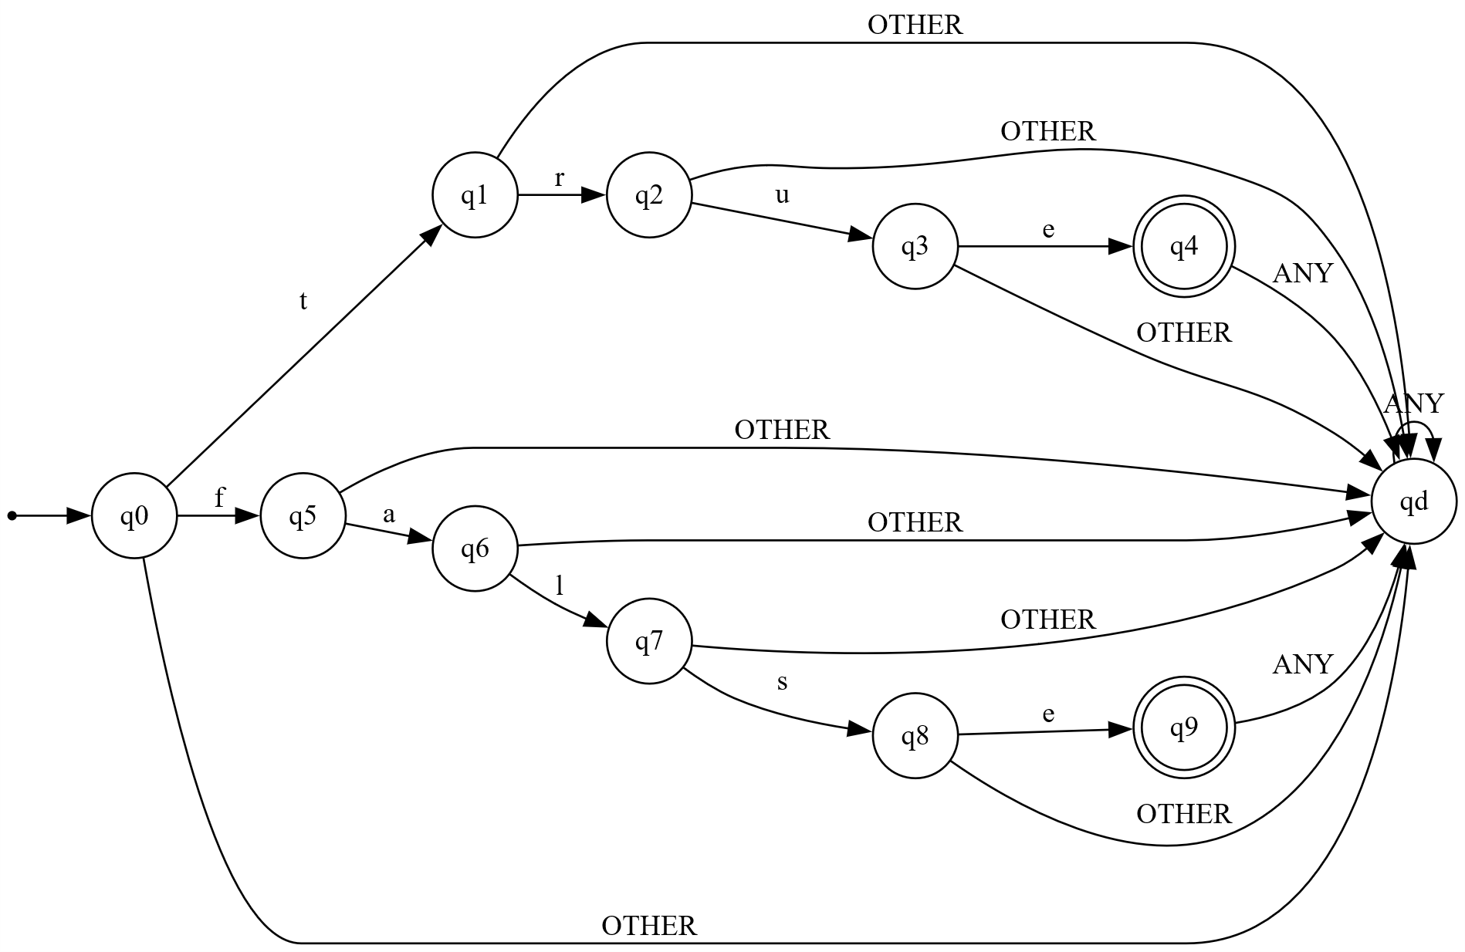

3.3 Float
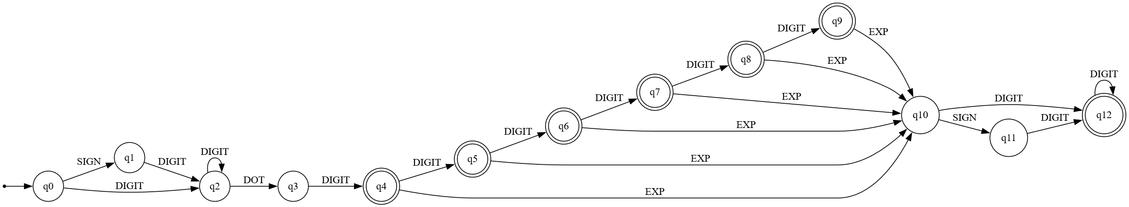

3.4 ID
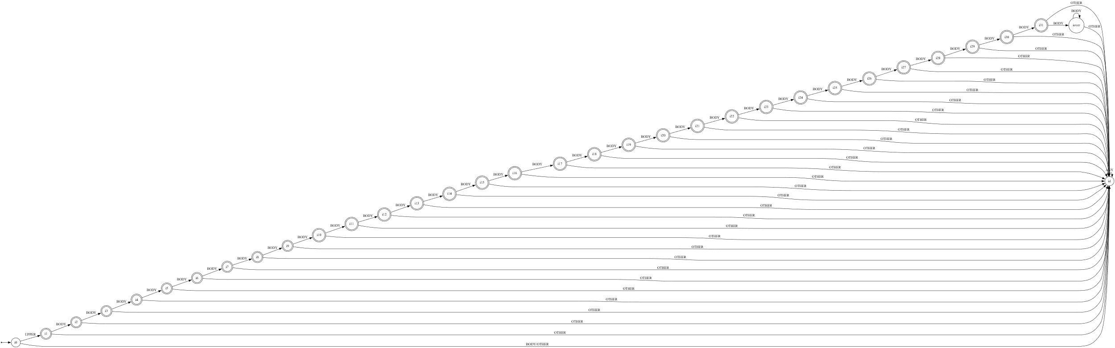

3.5 Integer
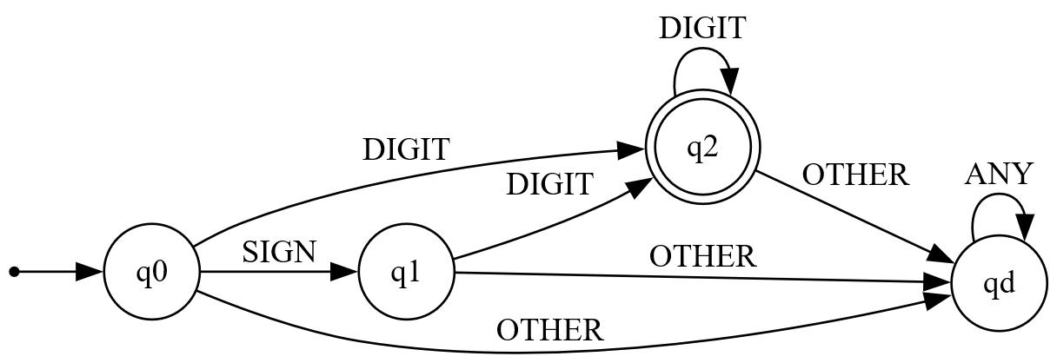

3.6 Punctuator
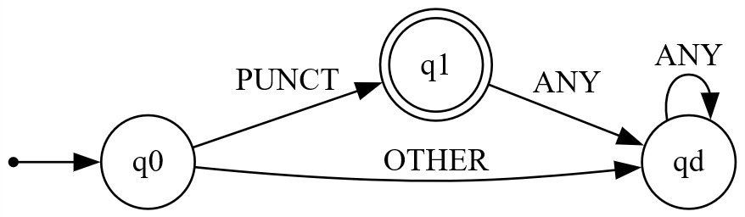

3.7 Single-line comment
